Oven Braised Corned Beef
RECIPE
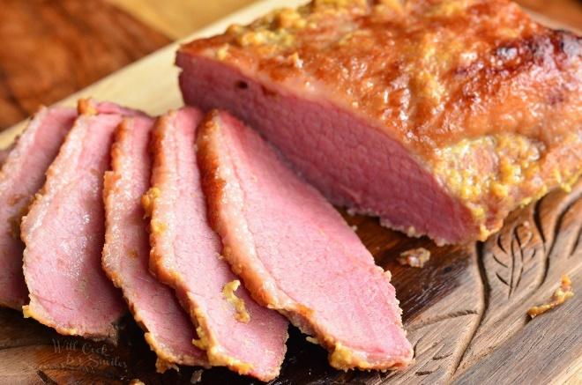
INGREDIENTS
- 6 pound corned beef brisket
- 2 cups water (apple juice can be substituted)
- 1 tablespoon onion powder
- 2 teaspoons thyme
- 2 teaspoons paprika
- 2 teaspoons garlic powder
- Optional Ingredients:
Dijon mustard, brown sugar

- Combine the spice packet with other dried ingredients. Using a spice grinder or a mortar and pestle, grind to desired texture. Set aside. (If no spice packet, add pepper and allspice to dried ingredients)
- Rinse corned beef brisket with cold water and pat dry.
- Use a large roasting pan or Dutch oven with a rack. It could take about one hour or more per pound to cook, depending on the thickness of the roast.
- Sprinkle seasoning mix on meat and pat into brisket.
- Since corned beef needs to cook with moist heat, you'll cover the pan or wrap the roast with aluminum foil to prevent it from drying out. Be sure to check the liquid as it cooks, replenishing it if needed. You can add vegetables during the last hour of cooking.

Prep Time: 10 minutes | Cook Time: 360 minutes | Total Time: 370 minutes | Yield: 20-24 servings

