Oven-Braised Beef Brisket
RECIPE
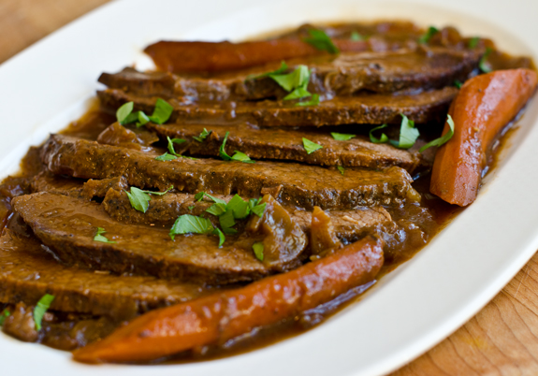
INGREDIENTS
- 1 (11#) beef brisket
- Salt and pepper
- 3 tablespoons flour
- 6 tablespoons vegetable oil
- 16 medium onions, sliced ½ inch thick
- 6 tablespoons tomato paste
- 6 cloves garlic, smashed and peeled
- 6 carrots, peeled and halved

DIRECTIONS
- Preheat oven to 325 degrees. Fan speed high. Spray a deep pan with non-stick spray.
- Trim brisket so small amount of fat is on top. Season with salt and pepper. Lightly dust brisket with flour on both sides.
- Heat oil in large skillet over medium-high heat. Add brisket; sear on both sides (approx. 5-7 minutes per side).
- Remove brisket and set aside.
- Add sliced onion to skillet and stir constantly until onions are golden brown. Place onions in prepared pan. If there are any brown bits in skillet, add a little water to loosen and place in pan with onions.
- Place brisket fatty side up and any juices on top of onions. Spread tomato paste on top of brisket. Scatter garlic and carrots around edges of brisket. Cover with foil and bake in oven for 1½ hours.
- Transfer brisket to cutting board and slice meat across grain into ¼-inch thick slices. Return slices to pan overlapping the slices. If needed add a little water. Cover and bake at 300 degrees for 2-2½ hours or until meat is fork tender. Check occasionally to make sure there is a little water in bottom of the pan while brisket is baking.

Prep Time: 5 minutes | Cook Time: 4 hours | Total Time: 265 minutes | Yield: 22 servings

