Orange Glazed Pork Loin
RECIPE
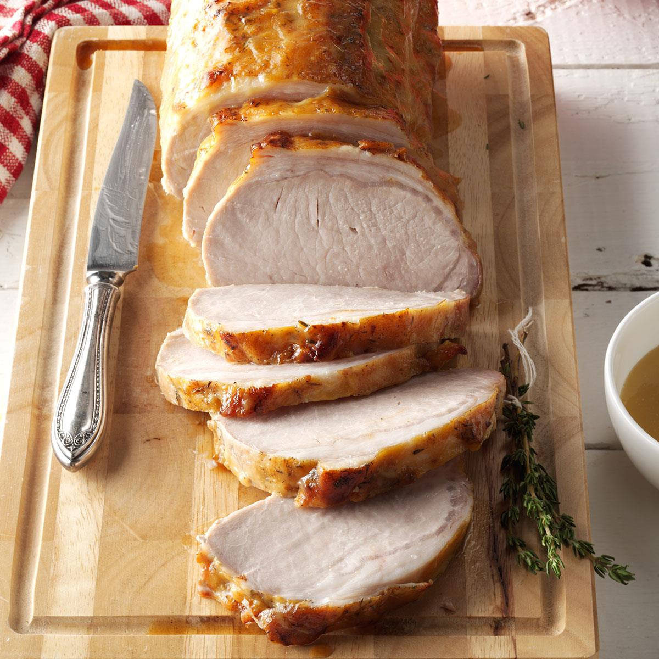
INGREDIENTS
- 1 teaspoon salt
- A tablespoon minced garlic
- ¼ teaspoon dried thyme
- ¼ teaspoon ground ginger
- ¼ teaspoon pepper
- 5 pound pork loin Item

For glaze
- 1 cup orange juice
- ¼ cup packed brown sugar
- 1 tablespoon Dijon mustard
- 1/3 cup cold water
- 1 tablespoon cornstarch

DIRECTIONS
- Preheat oven to 325⁰ F. Combine the first five ingredients; rub over roast. Place fat side up on a rack in a shallow roasting pan. Bake, uncovered, for one hour.
- Meanwhile, in a saucepan over medium heat, combine orange juice, brown sugar, Dijon mustard. In a small bowl mix water and cornstarch until smooth. Add to orange juice mixture and bring to a boil; cook and stir two minutes. Reserve I cup glaze for serving; brush half of remaining glaze over roast
- Bake until thermometer reads 145⁰, about 20-40 minutes longer, brushing occasionally with remaining glaze. Reheat reserved glaze; serve with roast.

Prep Time: 15 minutes | Cook Time: 80 minutes | Total Time: 95 minutes | Yield: 24 servings

