Orange Chicken
RECIPE
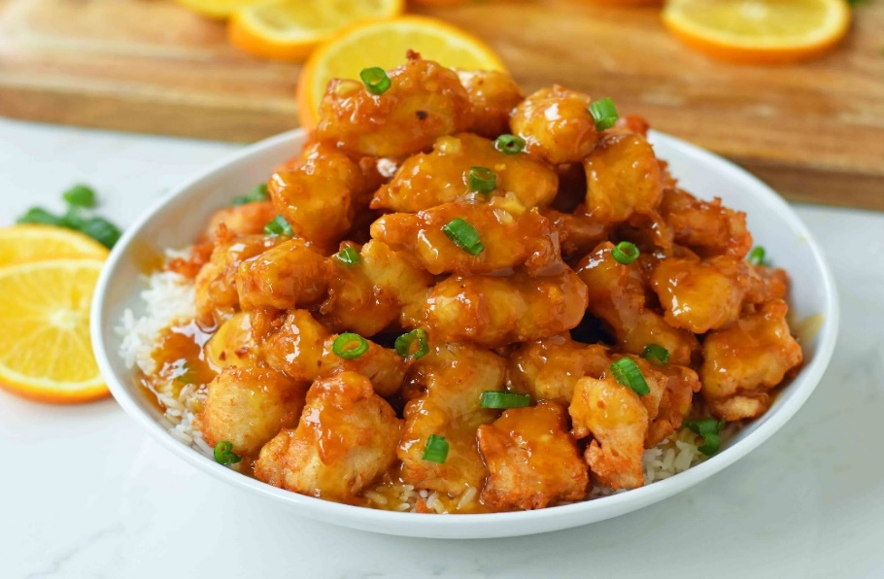
INGREDIENTS
- 5 pounds frozen fully cooked breaded chicken breast chunks
- Optional Ingredients:
sesame seeds, green onions

For Sauce
- 5 cups orange juice
- 2 ½ cups sugar
- 2/3 cup white vinegar
- 2/3 cup low sodium soy sauce
- 1 ¼ teaspoon ground ginger
- 1 ¼ teaspoon garlic powder
- orange zest from 5 oranges
- 1/3 cup cornstarch
- 2/3 cup water
- Optional Ingredients:
sesame seed, red chili flakes, minced garlic, brown sugar

DIRECTIONS
- Preheat oven to 375degrees. Place chicken chunks on tray and bake as directed on package.
- For sauce: mix together orange juice, sugar, vinegar, soy sauce, ginger, garlic powder and optional red chili flakes in a pot. Cook for 3 minutes. In a small bowl, mix cornstarch and water. Add cornstarch mixture to sauce, stir and continue to cook for 5 minutes to thicken. Removes from heat and add orange zest. Do not add chicken to sauce. Pour sauce over chicken when served.

Prep Time: 20 minutes | Cook Time: 30 minutes | Total Time: 50 minutes | Yield: 20 servings

