Open-Faced Chicken Cordon Bleu
RECIPE
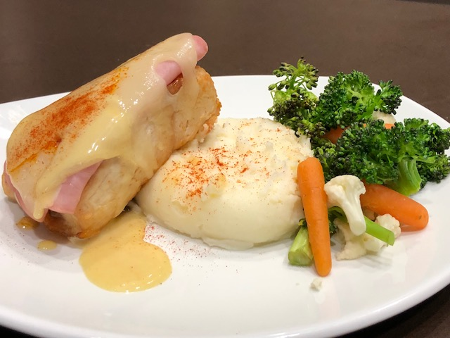
INGREDIENTS
- 20 boneless chicken breasts
- 40 slices buffet style or deli sliced ham
- Salt and pepper
- 20 slices Swiss cheese
- 2 ½ cups honey mustard dressing
- Optional Ingredients:
Provolone cheese, mozzarella cheese

For Sauce
- 2 cups honey
- 1 cup Dijon or yellow mustard

DIRECTIONS
- Preheat oven to 350 degrees. Prepare baking sheet with parchment paper or spray with non-stick spray.
- Mix honey and mustard together for the sauce and set aside.
- Place chicken breast on baking tray and season with salt and pepper.
- Place chicken in oven and bake 35-40 minutes or until internal temperature reaches 165 degrees.
- Fold 2 slices of ham in half and layer the slices on top of chicken.
- Place 1 slice of cheese over ham slices. Place chicken back in oven until cheese melts (may also use broiler making sure cheese melts and does not brown)
- Spoon honey mustard dressing over chicken.
- Sprinkle paprika on top and serve.

Prep Time: 10 minutes | Cook Time: 35-40 minutes | Total Time: 45-50 minutes | Yield: 20 servings

