Sweet Onion Pork Chops
RECIPE
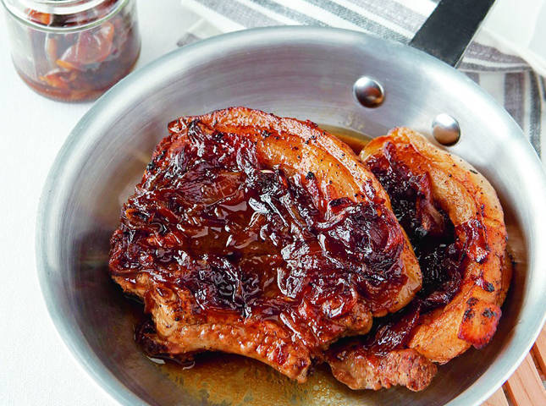
INGREDIENTS
- 24 pork chops
- 6 tablespoons oil
- 3 large onions, chopped
- 1 ½ cup pineapple juice
- 6 tablespoons brown sugar
- 6 tablespoons cider vinegar
- 1 ½ teaspoons salt

DIRECTIONS
- Preheat oven to 350 degrees. Spray a 2” pan with non-stick spray.
- Heat oil in a skillet and brown chops 2-3 minutes on each side. (You can also saute onions in skillet until soft before adding to pan if desired).
- Place chopped onions in bottom of pan and place browned chops on top.
- In a bowl, combine pineapple juice, brown sugar, cider vinegar and salt. Pour over chops
- Bake at 350 degrees for 45-55 minutes. Internal temperature should be 145 degrees. Serve chops with a spoon of the cooked onions on top.

Prep Time: 20 minutes | Cook Time: 45-55 minutes | Total Time: 65-75 minutes | Yield: 24 servings

