Mushroom Gravy Pork Chops
RECIPE
INGREDIENTS
- 24 pork chops
- Salt and pepper
- 5 tablespoon butter
- 3 ¾ cups milk
- 5 (10.75 ounce) can cream mushroom soup
- Optional Ingredients:
Mushrooms, sour cream, ground mustard, fried onions, parsley, chicken broth, ginger, rosemary

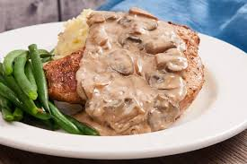

DIRECTIONS
- Preheat oven to 350 degrees.
- Season pork chops with salt and pepper to taste. Melt the butter in a large skillet over medium high heat. Brown pork chops in the butter about 2-3 minutes per side.
- In a separate medium bowl, combine the milk and soup. Place the pork chops in a 2” pan and pour the soup mixture over the chops.
- Bake at 350 degrees for 50-60 minutes. Internal temperature should be 145 degrees.

Prep Time: 20 minutes | Cook Time: 50-60 minutes | Total Time: 80-90 minutes | Yield: 24 servings

