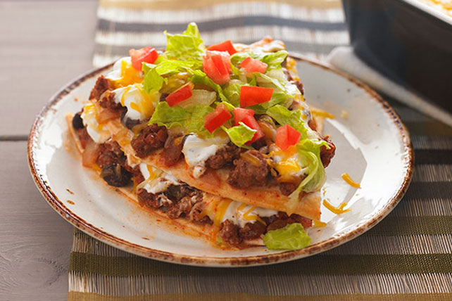
Mexican Lasagna
RECIPE
INGREDIENTS
- 4 pounds ground beef (could also use cooked pulled chicken)
- 3 large onions, chopped
- 6 cups mild salsa
- ½ (#10) can black beans, rinsed and drained
- ¾ cup Italian dressing
- 1/3 cup taco seasoning
- 18 flour tortillas (8”)
- 2 ½ cups sour cream
- 3 cups cheddar jack cheese
- 3 cups lettuce, chopped
- 3 medium tomatoes, diced
- Optional Ingredients:
green onions, cilantro, cumin, garlic powder, oregano

DIRECTIONS
- Heat oven to 370°F. Fan speed high. Spray 2” pan with non-stick spray.
- In a skillet, cook beef and onion over medium-high heat stirring occasionally, until thoroughly cooked; drain off excess grease.
- Stir in salsa, beans, Italian dressing and taco seasoning.
- Place half of the tortillas on the bottom of the prepared pan. Spread half of the meat mixture, sour cream and cheese over tortillas. Repeat for a second layer.
- Cover and bake for 25-30 minutes. Uncover and bake 5-10 minutes until internal temperature is 165 degrees and cheese is good and melted. Let stand for 5 minutes; top with lettuce and tomato.

Prep Time: 20 minutes | Cook Time: 45-50 minutes | Total Time: 65-70 minutes | Yield: 24-26 servings

