Mexican Baked Fish
RECIPE
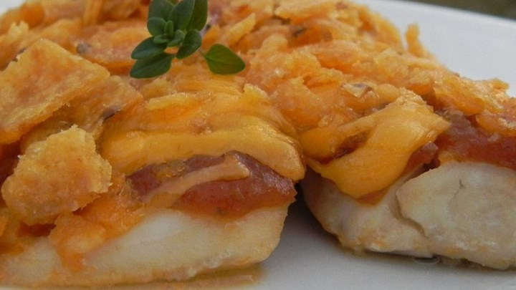
INGREDIENTS
- 24 fish fillets
- 4 cups mild salsa
- 4 cups shredded cheddar cheese
- 2 cups corn chips, crushed
- Optional Ingredients
parsley, cilantro

DIRECTIONS
- Preheat oven to 350 degrees. Fan speed high. Line a sheet pan with parchment and spray with non-stick spray.
- Rinse fish fillets under cold water and dry pat with paper towels. Lay fillets side by side on prepared pan.
- Pour salsa on top of each fillet, followed with a layer of chees and topped with crushed corn chips.
- Bake uncovered approximately 15 minutes or until fish flakes easily and is cooked.

Prep Time: 15 minutes | Cook Time: 15 minutes | Total Time: 30 minutes | Yield: 24 servings

