“Melt in Your Mouth” Chicken
RECIPE
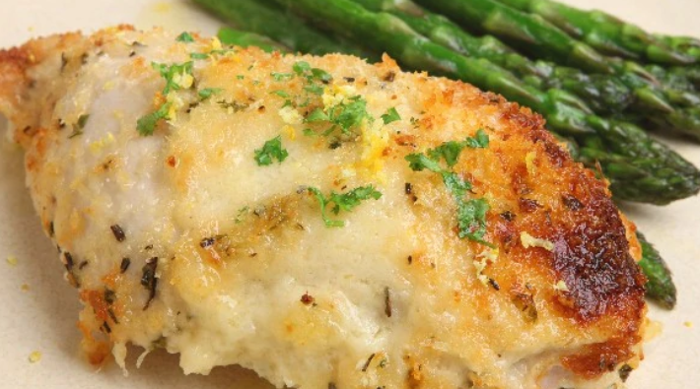
INGREDIENTS
- 24 (4oz) boneless skinless chicken breasts
- 6 cups mayonnaise
- 3 cups parmesan cheese
- 2 tablespoons garlic powder
- 1 tablespoon salt
- 1 tablespoon pepper
- Optional Ingredients:
fresh chopped parsley, dried parsley

DIRECTIONS
- Heat oven to 375 degrees. Spray baking pan with non-stick spray.
- Lay chicken flat in pan.
- Mix mayonnaise, cheese, garlic, salt and pepper in a small bowl.
- Spread mixture over chicken.
- Bake 25-35 minutes until chicken is cooked through reaching internal temperature of 165 degrees.
- Garnish with optional parsley.

Prep Time: 10 minutes | Cook Time: 25-35 minutes | Total Time: 35-45 minutes | Yield: 24 servings

