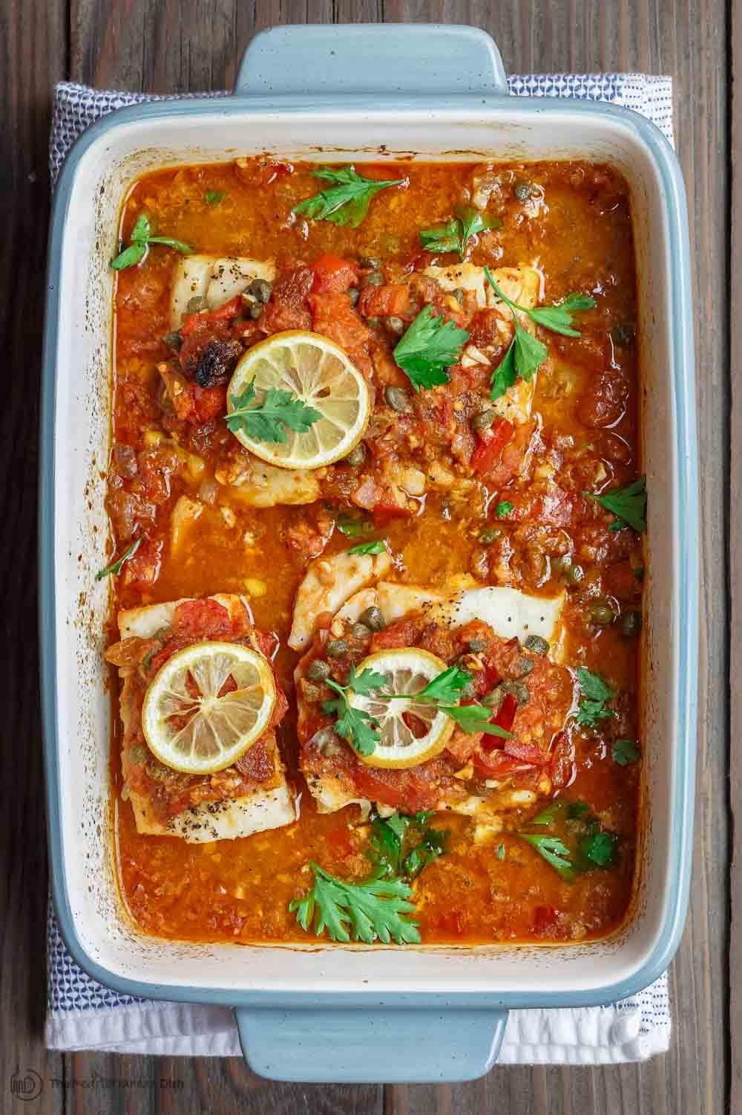
Mediterranean Baked Fish
RECIPE
INGREDIENTS
- 24 fish fillets, 4 oz each
- 1/4 cup oil
- 2 large sweet onions, finely chopped
- 1 (#10) can zucchini and tomatoes
- 6 garlic cloves, chopped
- 1 tablespoon paprika
- Salt and pepper
- Juice of 2 lemons
- Zest of 2 lemons
- Parsley for garnish
- Optional Ingredients
cayenne pepper, black olives, green peppers

DIRECTIONS
- Preheat oven to 350 degrees. Spray 2” pan with non-stick spray.
- In a saucepan, heat oil over medium-high heat. Add onions, cook 3 minutes. Add tomatoes/zucchini, garlic, paprika, salt and pepper. Bring to a boil, turn heat down to medium-low and simmer for 15 minutes.
- Pat fish dry and season with salt and pepper on both sides.
- Pour 1/2 of the cooked sauce into the bottom of prepared pan. Arrange the fish on top. Add lemon juice and lemon zest, then top with the remaining sauce.
- Bake for 18-22 minutes or until fish is cooked through and flakes easily and internal temperature reaches 165 degrees. Remove from heat and garnish with fresh parsley.

Prep Time: 10 minutes | Cook Time: 33-37 minutes | Total Time: 43-47 minutes | Yield: 24 servings

