Meatloaf
RECIPE
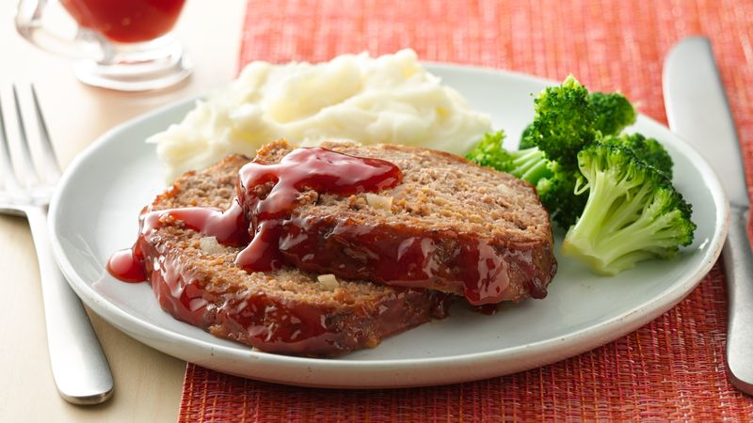
INGREDIENTS
- 5 pounds ground beef
- 4 eggs
- 3 medium onions chopped
- 3 cups dry breadcrumbs
- 2 cups milk
- Salt & pepper
- Optional Ingredients:
cracker crumbs, quick cooking oats, green pepper, garlic, garlic powder, parsley, thyme, onion powder, Worcestershire sauce, bacon, shredded cheddar cheese

For Topping
- 2/3 cup brown sugar
- 2/3 cup mustard
- 1-2/3 cup ketchup
- Optional Toppings:
bbq sauce

DIRECTIONS
- Preheat oven to 350 degrees. Prepare a 2” pan with non-stick spray.
- Combine ground beef, eggs, onion, milk and bread crumbs. Season with salt and pepper to taste. Add any preferred additional ingredients and mix.
- Form beef mixture into 2-3 loaves and place in prepared pan.
- In a separate bowl, combine brown sugar, mustard and ketchup. Mix well and spoon over meatloaves.
- Bake in oven for 1-1 ½ hours or until internal temperature reaches 165 degrees.

Prep Time: 10 minutes | Cook Time: 60-90 minutes | Total Time: 70-100 minutes | Yield: 20-26 servings

