Meatballs
RECIPE
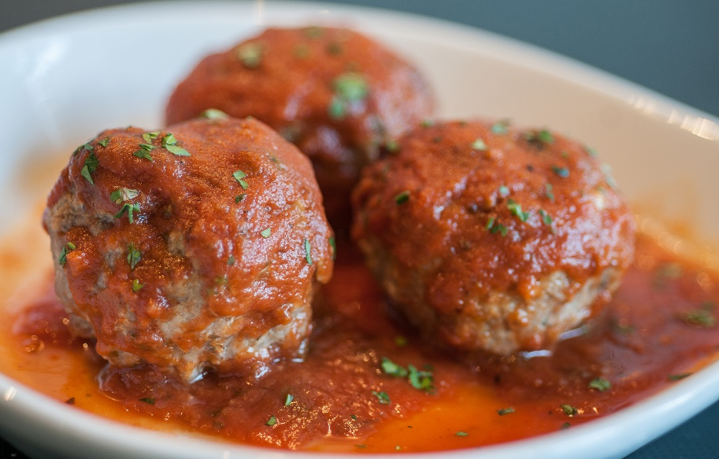
INGREDIENTS
- 5 pounds ground beef
- 5 eggs
- 1 ¼ cup bread crumbs
- ¾ cup milk
- 2 tablespoons dried parsley
- 2 ½ teaspoons garlic powder
- 1 ¼ cup Parmesan cheese
- Salt and pepper
- Optional Ingredients:
ground pork/chicken or sausage, garlic minced, onion, Italian seasoning, cracker crumbs, Worcestershire sauce
- Optional Sauces:
bbq sauce

DIRECTIONS
- Preheat oven to 375 degrees. Fan speed high. Prepare pans with parchment paper.
- In a large bowl, mix together all ingredients for the meatballs.
- Using a 1-ounce scoop, form meatballs. Place meatballs on prepared pan.
- Bake for 20 minutes or until internal temperature is 165 degrees.
- Heat large pot to medium-low heat.
- Add 1-2 cans of pasta sauce.
- Add meatballs to pot and heat, turning to coat well.

Prep Time: 15 minutes | Cook Time: 25 minutes | Total Time: 40 minutes | Yield: 20-26 servings

