Marinated VegetableSalad
RECIPE
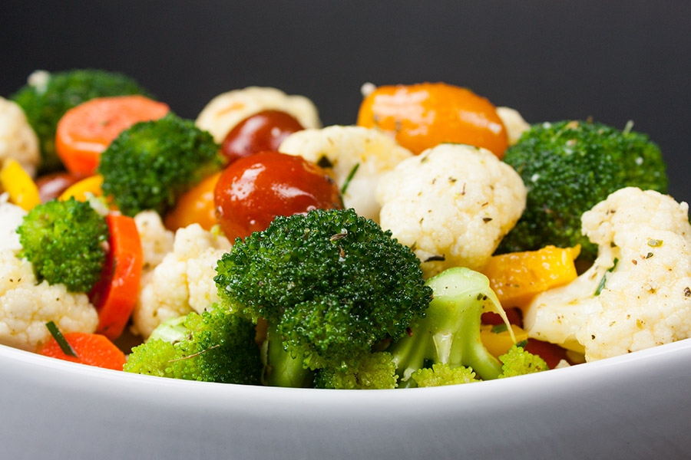
INGREDIENTS
- 6 cups cauliflower florets
- 4 cups broccoli florets
- 4 cups tomatoes, diced if not cherry or grape tomatoes
- 4 cups carrots, sliced into bite-size pieces (2-3 medium carrots)
- 2 yellow bell pepper, cut into bite-size pieces red or orange will also work)

For Vinaigrette
- 1 cup extra virgin olive oil
- 1 cup red wine vinegar
- 6 Tablespoons chives, chopped
- 1 teaspoon dry ground mustard
- 4 teaspoons Italian seasoning
- 4 cloves garlic, pressed or minced pressed or minced
- Salt and pepper

DIRECTIONS
- Add the vegetables to a large bowl.
- To make the vinaigrette
- Add the olive oil, red wine vinegar, chives, dry mustard, Italian seasoning, garlic, salt, and pepper in a jar with a tight-fitting lid. Shake until combined. (you can also whisk these ingredients in a small bowl)
- Pour the vinaigrette over the vegetables, toss to coat evenly.
- Cover and refrigerate 4 hours to overnight. (overnight is best)

Prep Time: 20 minutes | Cook Time: 0 minutes | Total Time: 20 minutes | Yield: 20 servings

