Baked Macaroni and Cheese
RECIPE
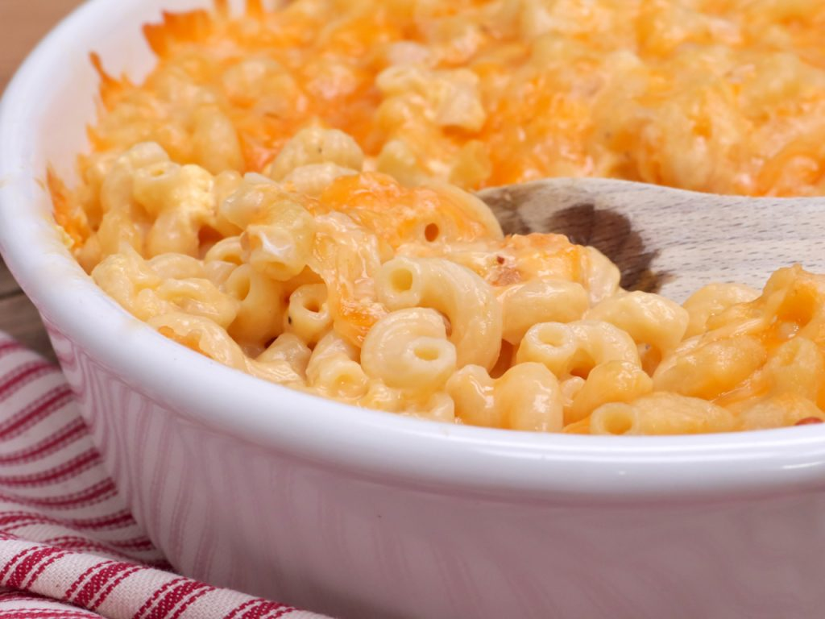
INGREDIENTS
- 9 cups elbow macaroni
- 6 tablespoons butter
- 6 tablespoons flour
- 6 cups milk
- 1 ½ cups heavy cream
- Salt and pepper
- 6 eggs, slightly beaten
- 12 cups cheddar jack cheese
- Optional Ingredients:
cayenne pepper, dry mustard, nutmeg, paprika

DIRECTIONS
- Pre-heat the oven to 350 degrees. Spray a 2” pan with non-stick spray.
- Cook the pasta in salted water until al dente, drain and set aside.
- In a large pot, melt butter on medium-low heat. Whisk in flour and continue stirring until golden.
- Whisk in heavy cream and half the milk. Stir until smooth. Add 3 cups of cheese and stir until smooth.
- Pour sauce over macaroni tossing to coat. Set aside.
- In a large bowl add the rest of milk and 8 cups of cheese. Salt and pepper to taste. Add in eggs and stir until mixed in. Pour egg mixture over macaroni and mix. Place into prepared pan.
- Sprinkle top with remaining 1 cup of cheese,
- Bake for 30-35 minutes, uncovered. Let sit for 10 minutes before serving.

Prep Time: 10 minutes | Cook Time: 20 minutes | Total Time: 30 minutes | Yield: 24 servings

