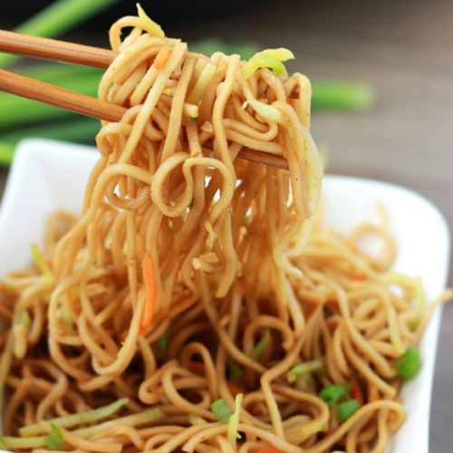
Lo Mein
INGREDIENTS
- 5 pounds of cooked spaghetti
- 3+ tablespoons oil
- 1 bag coleslaw mix
- 3 small onions, sliced
- Optional Ingredients:
linguini, mushrooms, green onions

Sauce Ingredients
- 2 ½ cups oyster sauce
- ½ cup low sodium soy sauce
- ¾ cup granulated sugar
- 2 tablespoons apple cider vinegar
- 6 garlic cloves, minced
- ½ teaspoon dried ginger
- ¼ teaspoon pepper
- Optional Ingredients:
white pepper, sesame oil, brown sugar, Hoisin sauce, rice vinegar

RECIPE

DIRECTIONS
- Toss cooked pasta in small amount of oil to prevent sticking.
- Heat a large skillet to medium-high heat. Add 3 tablespoons of oil, coleslaw and onions. Stir and cook until vegetables are seared and tender.
- Mix together ingredients for sauce and add to cooked vegetables and heat through.
- Add noodles and serve.

Prep Time: 15 minutes | Cook Time: 30 minutes | Total Time: 45 minutes | Yield: 20 servings

