Liver and Onions
RECIPE
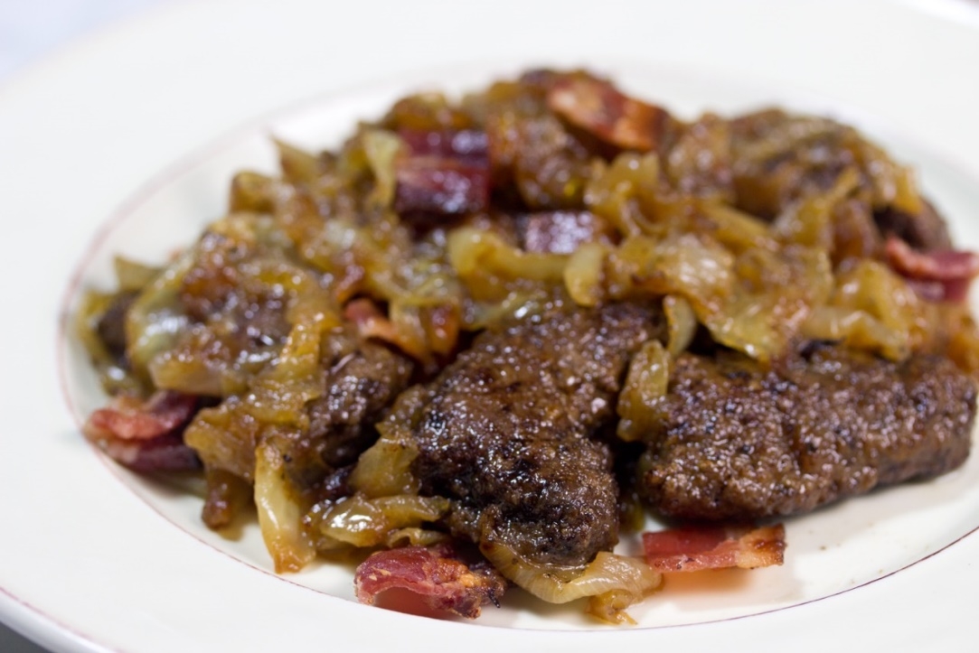
INGREDIENTS
- 8 yellow onions, sliced
- 1 pound bacon, chopped into 1” pieces
- 4 tablespoons butter
- 4 tablespoons olive oil
- 3 tablespoons dried parsley
- 1 tablespoon brown sugar
- 2 cups soy sauce
- 1 cup liquid smoke
- 10 pounds beef liver (about 40 slices)
- 4 cups flour
- Pepper

- Preheat oven to 350 degrees. Spray a 2” pan with non-stick spray.
- Cook onions and bacon in butter and oil until the onions are almost translucent.
- Add the soy, smoke, parsley, and brown sugar to the onion mixture and bring to a boil, then turn off the heat.
- Season flour with pepper. Lightly coat each liver piece in the seasoned flour. Shingle slices in a 2” pan (40 pieces of liver will fill roughly 2 pans).
- Pour the onion mixture evenly over the coated liver, seal tightly with foil and bake for 50 minutes.
- Let meat rest in the warmer covered for about 10 minutes before serving. Tender every time.

Prep Time: 30 minutes | Cook Time: 70 minutes | Total Time: 100 minutes | Yield: 40 servings

