Lemon Cream Fish
RECIPE
INGREDIENTS
- 20 fish fillets, 4 oz each
- 1 ¼ cup butter
- 1 ¼ cup heavy cream
- 7 garlic cloves minced
- 5 tablespoons Dijon mustard
- ½ cup lemon juice
- Salt & pepper
- Dried or fresh parsley
- Optional Ingredients:
Garlic powder, chopped garlic, lemons sliced, chopped scallions or red onions

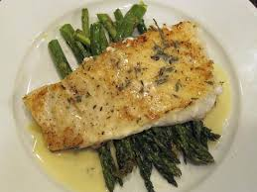

DIRECTIONS
- Preheat oven to 400°F and spray non-stick spray in sheet pan.
- Pat fish dry with paper towels to remove excess water. Very important, otherwise sauce will be too thin and watery. Place fish in pan – ensure fish isn’t crammed in too snuggly.
- Sprinkle both sides of fish with salt and pepper. Place butter, heavy cream, garlic, mustard, lemon juice and any desired optional ingredients in a microwave container. Microwave in 30 second bursts until melted and smooth.
- Pour sauce over fish and sprinkle with parsley.
- Bake 10-12 minutes or until fish is just cooked.
- To serve, spoon sauce over fish.

Prep Time: 20 minutes | Cook Time: 10-12 minutes | Total Time: 30-32 minutes | Yield: 20 servings

