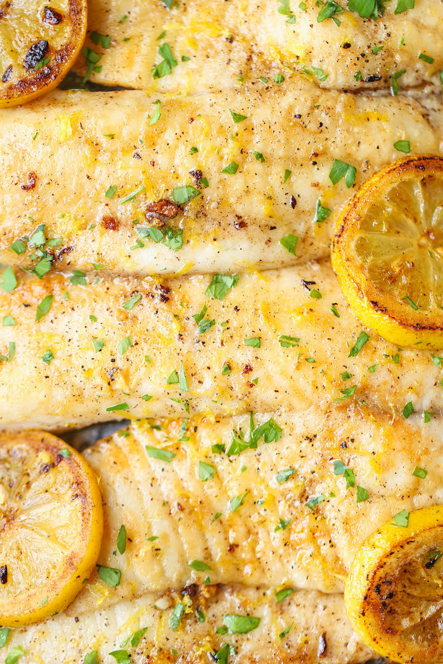
Lemon Butter Baked Fish
RECIPE
INGREDIENTS
- 20 fish fillets, 4 oz each
- 1 ¼ cup butter, melted
- 15 garlic cloves minced
- 2/3 cup lemon juice
- Zest of 5 lemons
- Salt & pepper
- Dried or fresh parsley
- Optional Ingredients:
Garlic powder, chopped garlic, lemons sliced, chopped scallions

DIRECTIONS
- Preheat oven to 400°F and spray non-stick spray in sheet pan or line with parchment.
- In a small bowl, whisk together butter, garlic, lemon juice and zest. Set aside.
- Pat fish dry with paper towels to remove excess water. Place fish on sheet pan – ensure fish isn’t crammed.
- Sprinkle both sides of fish with salt and pepper.
- Drizzle with butter mixture.
- Bake 10-12 minutes or until fish is just cooked and flakes easily with fork.
- Garnish with parsley for added color.

Prep Time: 20 minutes | Cook Time: 10-12 minutes | Total Time: 30-32 minutes | Yield: 20 servings

