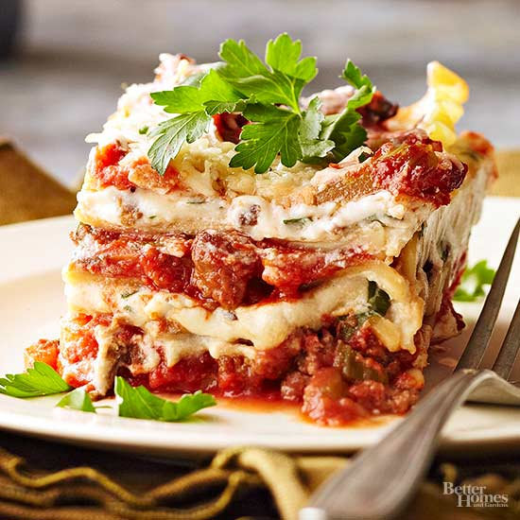
Lasagna
RECIPE
INGREDIENTS
- 4 pounds ground beef
- 2 teaspoons garlic powder
- Salt and pepper
- 12 cups pasta sauce
- 18 cooked lasagna noodles
- Optional Ingredients:
Pork sausage, minced garlic, red pepper flakes, zucchini, spinach, onion, parsley, oregano, sugar, vinegar

For Cheese Mixture
- 4 ½ -5 cups of ricotta cheese
- 2 ½ cups mozzarella cheese, shredded
- ¾ cup Parmesan cheese
- 3 eggs
- 3 teaspoons Italian seasoning
- Optional Ingredients:
Cottage cheese in place of mozzarella

DIRECTIONS
- Cook beef, garlic powder and salt and pepper in a large skillet over medium heat, stirring until it crumbles and is no longer pink; drain.
- Stir in pasta sauce.
- Mix ricotta, mozzarella, parmesan, eggs and Italian seasoning in a large bowl.
- Spread one-third of meat sauce in a lightly greased 2” pan. Layer with 9 cooked noodles and half of cheese mixture. (Tip: place the cheese mixture in a zip lock bag, cut off the tip to one corner of the bag and pipe cheese onto meat sauce; then spread thin). Repeat procedure. Finally, top with remaining meat sauce.
- Tightly cover baking dish with plastic wrap and aluminum foil.
- Bake at 350° for 60-70 minutes; uncover (additional mozzarella cheese may be added to top) and bake 10 more minutes or until internal temperature reaches 165 degrees. Let stand 10 minutes before serving.

Prep Time: 20 minutes | Cook Time: 60-80 minutes | Total Time: 80-100 minutes | Yield: 24 servings

