Kielbasa and Potatoes
Note: No need for an additional carbohydrate since the main dish contains pasta
RECIPE
INGREDIENTS
- 5 pound of Kielbasa sausage cut into 1 inch pieces
- 20 potatoes, peeled, cut into 1 inch cubes
- 5 onions, chopped
- 8 green bell peppers, cut into 1 inch pieces
- 2 ½ teaspoons onion powder
- 2 ½ teaspoons garlic powder
- Salt and pepper
- ¾ cup olive oil
- Optional Ingredients:
carrots, garlic cloves
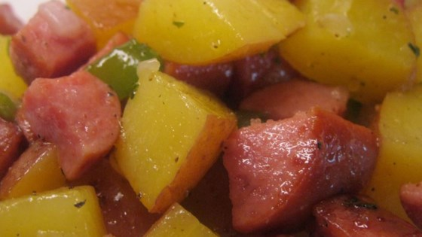

DIRECTIONS
- Preheat oven to 350 degrees. Spray a sheet pan(s) with non-stick spray.
- Mix kielbasa, potatoes, onions, peppers together and place on pan. Season with salt pepper, onion powder and garlic powder. Drizzle oil over the mixture and stir to coat.
- Cover with foil and bake in preheated oven for 1 hour.
- Remove foil and bake until potatoes are completely cooked, about 30 minutes more.

Prep Time: 15 minutes | Cook Time: 135 minutes | Total Time: 150 minutes | Yield: 20 servings

