Kielbasa and Sauerkraut
RECIPE
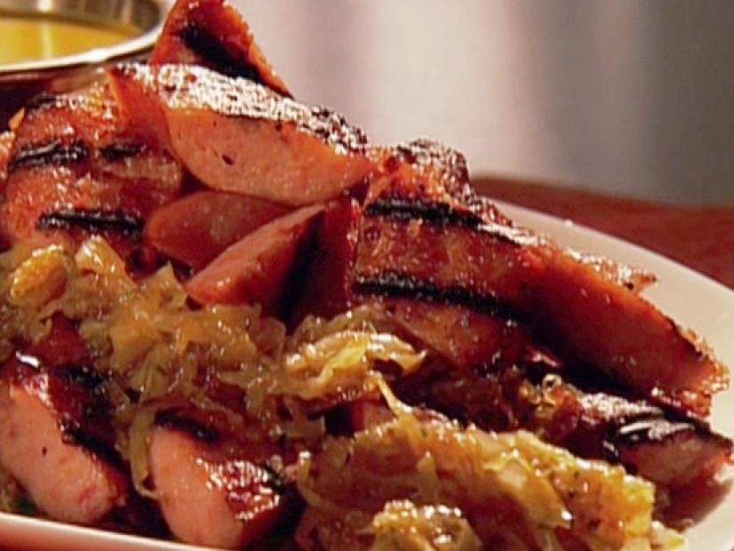
INGREDIENTS
- 5 pounds smoked Polska kielbasa
- 6 tablespoons butter
- 2/3 cup sugar
- 3-4 onions, sliced
- 1-2 (#10) cans sauerkraut, drained
- 1 tablespoon dried parsley leaves

DIRECTIONS
- Preheat grill. Preheat oven to 400 degrees F.
- Cut kielbasa into 3-inch lengths and butterfly lengthwise. Place on hot grill and cook for 4 to 5 minutes on each side turning frequently, charring all sides. Remove from grill. Transfer kielbasa to a baking sheet and place in oven to cook for another 5 to 6 minutes.
- In a large skillet over medium-high heat, add butter and sugar. Allow sugar to cook to a golden brown color. Add onions and cook until caramelized. Stir in the sauerkraut and cook for 5 to 6 minutes until onions and sauerkraut are wilted and colored.
- Remove kielbasa from oven and cut into 1-inch pieces. Add to pan of sauerkraut and onions. Toss together and cook for 1 minute. Garnish with parsley to serve.

Prep Time: 15 minutes | Cook Time: 25 minutes | Total Time: 40minutes | Yield: 20 servings

