Italian Pork Chops
RECIPE
INGREDIENTS
- 24 pork chops
- Salt and pepper
- 3 tablespoons oil
- 3 large onion, sliced
- 3 large green pepper
- 1 10# can stewed or diced tomatoes
- 1 ½ teaspoon dried basil
- 1 ½ teaspoon dried oregano
- 3-4 garlic cloves, chopped
- Optional Ingredients:
mushrooms, garlic powder, onion powder

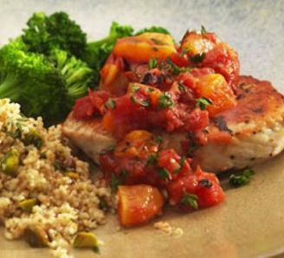

DIRECTIONS
- Preheat oven to 350 degrees.
- Heat oil in skillet over medium heat. Season chops with salt and pepper. Brown pork chops in oil on both sides, about 2-3 minutes on both sides and place in a 2” pan.
- Arrange sliced onions and peppers on the bottom of a casserole dish and place pork chops on top.
- If using mushrooms, put them on top of pork chops then cover with tomatoes. Add basil, oregano and garlic.
- Bake, covered for 50 minutes.
- Remove cover and bake for 20 minutes longer. Internal temperature should be 145 degrees.

Prep Time: 10 minutes | Cook Time: 80 minutes | Total Time: 90 minutes | Yield: 24 servings

