Honey Mustard Salmon
Note: Purchase salmon from OFH when available
RECIPE
INGREDIENTS
- 6 pounds of salmon, cut into piece

For Sauce
- ½ cup Dijon mustard
- ½ cup honey
- 9 cloves garlic, minced
- ½ cup olive oil
- 3 tablespoons lemon juice
- 1 ½ tablespoons dill
- salt & pepper

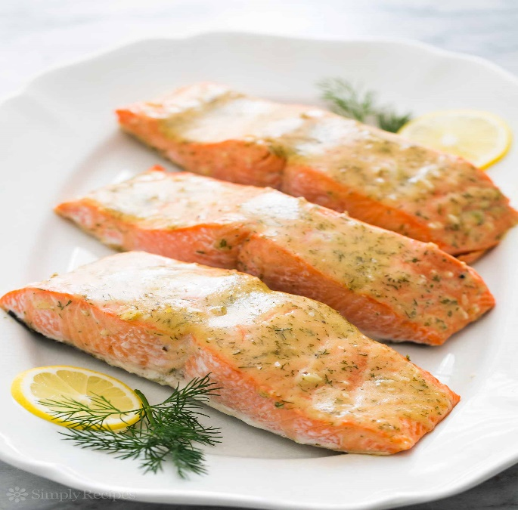

DIRECTIONS
- Preheat the oven to 350 degrees F. Line a sheet pan with parchment or spray with non-stick spray. Lay the salmon, skin side down, on pan. Set aside.
- In a small bowl, whisk together the mustard, honey, garlic, olive oil, lemon juice, dill, salt and pepper.
- Brush to coat the top side of the fillets with the honey mustard mixture.
- Bake uncovered 13-17 minutes or until salmon flakes easily and is cooked.

Prep Time: 10 minutes | Cook Time: 20 minutes | Total Time: 30 minutes | Yield: 20-24 servings

