Honey Mustard Chicken
RECIPE
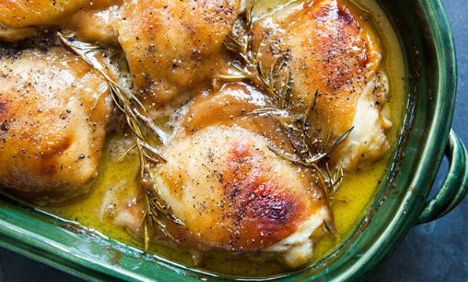
INGREDIENTS
- 24 chicken thighs
- 1 ½ cups Dijon mustard
- 1 ½ cups honey
- 6 tablespoons olive oil
- 1 tablespoon salt
- 1 ½ teaspoons pepper
- 1 tablespoon oregano
- Optional Ingredients:
chicken pieces or breasts, rosemary, cayenne pepper

DIRECTIONS
- Heat oven to 350 degrees. Spray baking pan with non-stick spray.
- In a small bowl, whisk together mustard, honey, olive oil, salt, pepper and oregano.
- Place chicken in prepared pan. Spoon mixture over chicken. Make sure chicken is evenly coated.
- Bake 30-40 minutes until chicken is cooked through reaching internal temperature of 165 degrees.

Prep Time: 5 minutes | Cook Time: 30-40 minutes | Total Time: 35-45 minutes | Yield: 24 servings

