Herb Crusted Salmon
RECIPE
Note: Purchase salmon from Ozark Food Harvest when available
INGREDIENTS
- 6 pounds of salmon
- salt & pepper
- 6 tablespoon butter, melted
- juice of 2 lemons

FOR TOPPING
- 2 ¼ cup seasoned bread crumbs
- 9 cloves garlic, minced
- 2 tablespoons parsley
- 2 teaspoons dill
- zest from two lemons
- 6 tablespoons parmesan cheese
- 9 tablespoons butter, melted

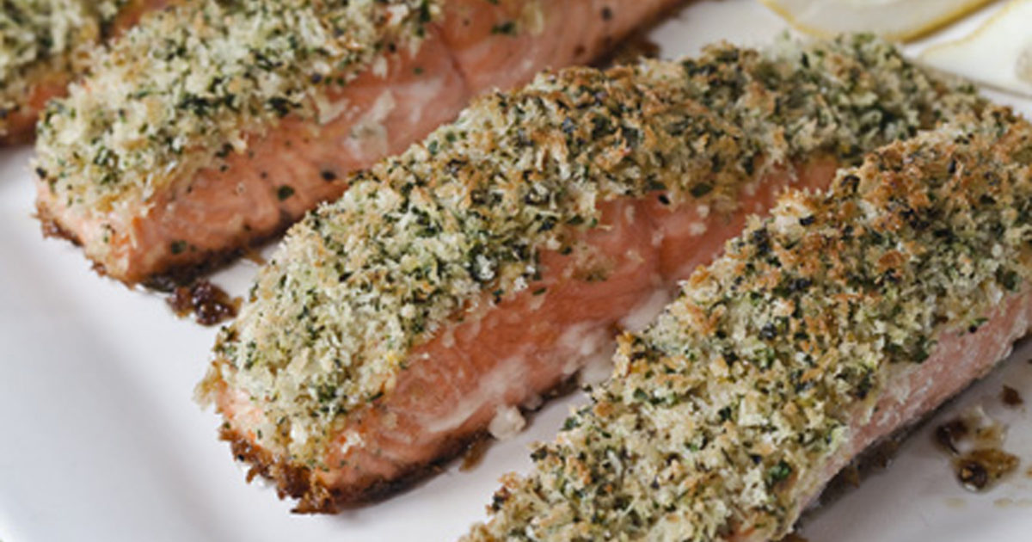

DIRECTIONS
- Preheat oven to 350 degrees. Line a sheet pan with parchment and spray with non-stick spray.
- Place salmon on the sheet pan and brush with melted butter. Season with salt and pepper and squeeze lemon juice over top.
- Combine first six ingredients for topping in a small bowl. Pour in melted butter and stir.
- Sprinkle crumb mixture over salmon. Bake uncovered 13-17 minutes or until salmon flakes easily and is cooked.

Prep Time: 10 minutes | Cook Time: 20 minutes | Total Time: 30 minutes | Yield: 20-24 servings

