**Hearty Beef Pot Roast**

RECIPE

**INGREDIENTS**

* 6 pound pot roast (juices reserved).
* 2 pounds fresh or frozen baby carrots
* 4 lbs. red skin potatoes (fresh)
* I cup frozen corn
* ½ cup frozen peas
* 1 medium onion coarsely chopped
* 1 cup diced celery
* Salt and pepper
* Optional Ingredients:

Garlic powder, garlic cloves, beef stock, rosemary, bay leaves, thyme

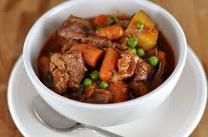

1. Place all ingredients, including the juices from roast, into roasting pan.
2. Bake for 2 ½ hours at 325 degrees

|  |  |  |  |
| --- | --- | --- | --- |
| **Prep Time:** 30 minutes | **Cook Time:** 120 minutes | **Total Time:** 150 minutes | **Yield:** 24 servings |