Baked Hawaiian Chicken
RECIPE
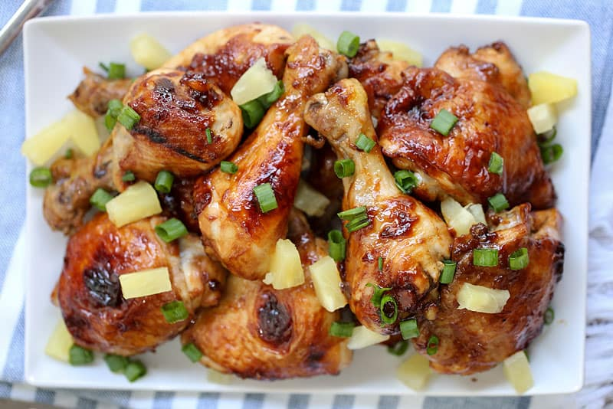
INGREDIENTS

- 24 chicken thighs
- 3 cups pineapple juice
- 1 cup light soy sauce
- ¾ cup rice wine vinegar
- ¾ cup brown sugar
- 6 tablespoons tomato paste
- 3 tablespoons garlic, minced
- 2 tablespoons ginger, grated
- 6 cups pineapple tidbits
- 3 onions, chopped
- Optional Ingredients:
chicken legs, ketchup, apple cider vinegar, honey, green onions

DIRECTIONS
- Preheat oven to 450°. If cooking at 400° or 425°, increase bake time. Spray a 2” pan with non-stick spray.
- Combine, juice, light soy sauce, vinegar, brown sugar, tomato paste, garlic and ginger in a large bowl. Stir to mix well and pour into prepared pan.
- Place chopped onions in pan and place chicken on top not overlapping. Add pineapple tidbits between (not on top) the chicken pieces.
- Bake 15 minutes, then baste with sauce. Continue to bake another 15 minutes until internal temperature reaches 165 degrees. Let rest 5-10 minutes.

Prep Time: 30 minutes | Cook Time: 30 minutes | Total Time: 60 minutes | Yield: 24 servings

