Ham and Beans
RECIPE
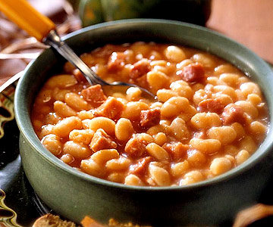
INGREDIENTS
- 3 pound dried beans
- 1 ½ pound cook ham, diced
- 3 small onion
- 1 ½ cup brown sugar
- ¾ teaspoon cayenne pepper
- 3 tablespoon dried parsley
- Salt and pepper
- Water
- Optional Ingredients
Celery, carrots cut fine, basil, garlic powder, chicken broth, marjoram

DIRECTIONS
- Night before: Rinse beans in a large pot; discard shriveled beans and any small stones. Add 8 cups of cold water. Let stand overnight or at least 8 hours. Drain and rinse beans.
- Drain and rinse beans. Place beans in large pot and add ham, onion, brown sugar, salt, pepper, cayenne and parsley and water to cover.
- Bring to a boil; reduce heat and simmer 2 to 2 ½ hours, until beans are tender. Add more water if necessary during cooking time.

Prep Time: 15 minutes | Cook Time: 120+ minutes | Total Time: 135+ minutes | Yield: 21 servings

