Ground Beef Gyros
RECIPE
INGREDIENTS
Tzatzika Sauce
- 5 cups sour cream
- 2 cups cucumber, seeded and shredded
- 1 ½ tablespoons dill
- 2 teaspoons garlic powder
- Salt and pepper
- Optional ingredients:
lemon juice, yogurt, parsley, sugar

Filling
- 5 pounds ground beef
- 2 tablespoons oregano
- 5 teaspoons garlic powder
- 5 teaspoons onion powder
- Salt and pepper
- 20 (6-inch) flour shells
- 15 cups shredded lettuce
- 5 large tomatoes, chopped
- 4 medium red onions, chopped
- Optional Ingredients:
pita bread, yellow onion, rosemary

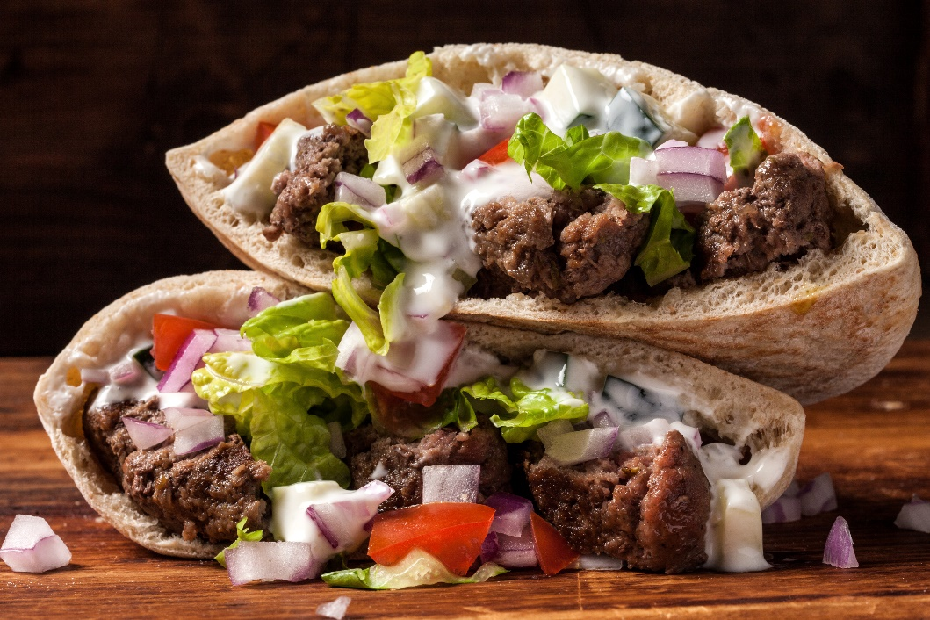

DIRECTIONS
- Mix ingredients for sauce. Cover and refrigerate.
- Combine ground beef and seasonings; form mixture into 20 patties.
- Fry patties until internal temperature reaches 165 degrees.
- Cut a patty into slices and place in shell. Add lettuce, tomato, onion. Repeat for remaining patties.
- Serve with Tzatzika sauce.

Prep Time: 15 minutes | Cook Time: 15 minutes | Total Time: 30 minutes | Yield: 20 servings

