Guacamole
RECIPE

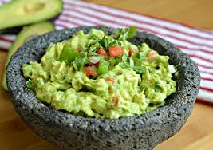
INGREDIENTS
- 15 avacados, peeled, pitted, mashed
- 5 limes, juiced
- 1 tablespoon salt
- 2 ½ cup diced onion
- ¾ cup cilantro
- 5 tomatoes, diced
- 5 teaspoons minced garlic
- Optional Ingredients:
Cayenne pepper

DIRECTIONS
- In a medium bowl, mash together the avocados, lime juice, and salt.
- Mix in onion, cilantro, tomatoes, and garlic.
- Refrigerate 1 hour for best flavor, or serve immediately.

Prep Time: 15 minutes | Cook Time: 0 minutes | Total Time: 15minutes | Yield: 20 servings

