Ground Beef Hobo Pack
RECIPE
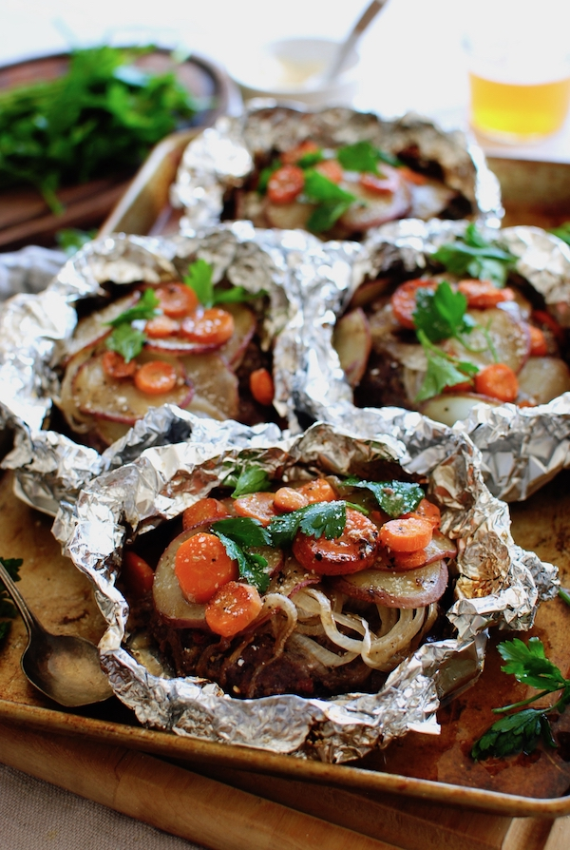
INGREDIENTS
- 20 pub patties
- 40 oz brown gravy
- 10 cups rosemary potatoes
- 20 cups vegetable
- Phase & Chef Shake

Note: This is just an example of the type of hobo pack you can create. Try using meatballs, pineapple and vegetables with sweet & sour sauce. Be creative

DIRECTIONS
- Tear off a large square of aluminum foil.
- Place ½ cup rosemary potatoes in center of foil.
- Lay beef patty on top of potatoes.
- Place 2 ounces of brown gravy on beef patty.
- Place 1 cup of vegetables around the edges of the beef patty.
- Season vegetables with Phase/Chef Shake mixture
- Seal foil package securely and freeze.
- When ready to heat and serve, preheat oven to 350 degrees. Bake for 25 minutes or until internal temperature reaches 165 degrees.

Prep Time: 20 minutes | Cook Time: 25 minutes | Total Time: 45 minutes | Yield: 20 servings

