Baked/Pan Seared/Grilled Fish
RECIPE
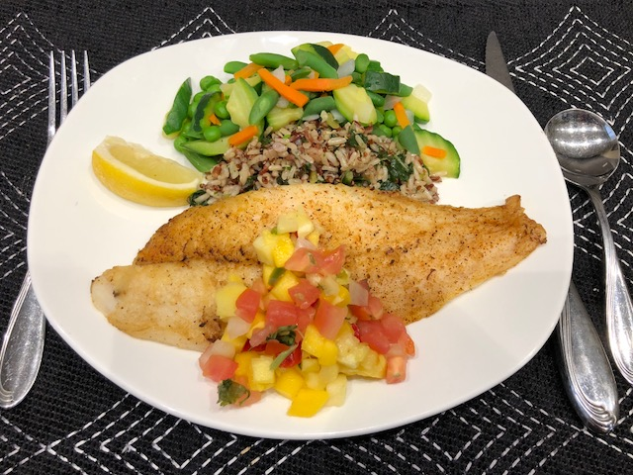
INGREDIENTS
- 20 fish fillets, 4 oz each
- Salt and pepper
- Paprika
- Optional seasonings:
Seasoning salt in place of salt, basil,
onion powder, garlic powder, dried grated lemon peel, thyme, chives, lemon pepper, parsley, cumin, chili powder

Spice Blend for Blackened Fish
- 1 tablespoon garlic powder
- 2 tablespoons onion powder
- 1 tablespoon cayenne
- 2 tablespoons paprika
- 1 tablespoon salt
- 1 tablespoon black pepper
- 1 tablespoon dried thyme
- ¾ teaspoon cumin

DIRECTIONS
- Rinse fish in cold water and pat dry with paper towels.
- Preheat grill or pan medium to medium-high heat. Spray non-stick spray or rub light coat of oil on pan or grill surface.
- Spray non-stick or brush light coat of oil on fish.
- Season both sides of fish with salt, pepper and paprika. Season with optional seasonings if desired.
- Grill fish for 3-5 minutes or until fish flakes easily with fork.
- May also bake fish if so desired.

Prep Time: 10 minutes | Cook Time: 3-5 minutes | Total Time: 13-15 minutes | Yield: 20 servings

