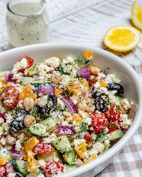 Greek Chickpea Salad + Tzatziki Dressing

Ingredients
- 3 cucumbers, chopped
- 2 large bell pepper yellow, red or green, chopped
- 5 cups cherry or grape tomatoes, halved
- 2 medium red onion, diced
- 1 #10 can of chickpeas or 6 cans 18 oz., drained and rinsed
- 1 cup olives of choice (pitted Kalamata) halved
- 1 ½ cup crumbled feta cheese (or blue cheese)

Tzatziki dressing:
- 1 1/2 cup sour cream (or plain Greek yogurt)
- 3 Tbsp. oil
- 6 Tbsps. lemon juice
- 8 fresh garlic cloves, (minced or pressed)
- 3 Tbsp. dill
- salt and black pepper to taste, (about 1 teaspoon each)

Instructions
- To make the dressing: place all the ingredients together and whisk really well in a small glass bowl.
- Keep refrigerated until ready to use.
- In a large bowl, arrange all salad ingredients. Pour dressing over, and gently toss to combine well.
- Allow flavors to blend for at least 10 minutes before eating

