Glazed Salmon
Note: Purchase salmon from Ozark Food Harvest when available
RECIPE
INGREDIENTS
- 6 pounds of salmon
- salt & pepper
- Optional Ingredients:
Garlic powder, onion powder, parsley, lemon slices

FOR GLAZE
- 6 tablespoons olive oil
- ¾ cup brown sugar
- ¾ cup low sodium soy sauce
- 9 garlic cloves, minced
- juice of three lemons

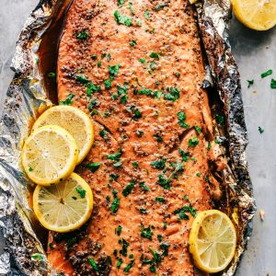

DIRECTIONS
- Preheat oven to 350 degrees. Spray a 2” pan with non-stick spray. Lay the salmon in pan and sprinkle with salt and pepper.
- In a small bowl whisk together the olive oil, brown sugar, soy sauce, garlic, and lemon juice. Pour glaze over salmon. Top with aluminum foil and seal.
- Bake for 20-25 minutes or until salmon is cooked throughout. Take the foil off of the top and baste the salmon with the sauce in the pan. Broil for 3-5 minutes or until brown and caramelized. Garnish with lemon slices and parsley if desired.

Prep Time: 10 minutes | Cook Time: 25 minutes | Total Time: 35minutes | Yield: 20-24 servings

