Glazed Ham Slices
RECIPE
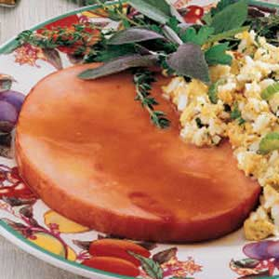
INGREDIENTS
- 1 ¼ cup packed brown sugar
- 4 ½ teaspoons all-purpose flour
- 1 ½ tablespoons ground mustard
- ¼ cup ginger ale
- ¼ cup cider vinegar
- 20 4-ounce ham slices

DIRECTIONS
- In a skillet, combine the brown sugar, flour, mustard, ginger ale and vinegar. Bring to a boil over low heat; cook and stir for 2 minutes or until sugar is dissolved and sauce is thickened.
- Lay ham out in 2-inch full cafeteria pan.
- Pour sauce over pan and cover with foil.
- Place ham in 350 degrees preheated oven until ham reaches 140 degrees.

Prep Time: 30 minutes | Cook Time: 35 minutes | Total Time: 65 minutes | Yield: 20 servings

