Fried Rice
RECIPE
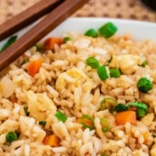
INGREDIENTS
- 9 cups day old cooked rice
- 6 tablespoons oil
- 3 small white onions, chopped
- 3 cups frozen peas and carrots, thawed
- 6-9 tablespoons soy sauce
- 6 eggs, lightly beaten
- Optional Ingredients
sliced green onions, sesame oil

DIRECTIONS
- Preheat a large skillet to medium heat. Pour oil in the bottom. Add white onion and peas and carrots and fry until tender.
- Slide the onion, peas and carrots to the side, and pour the beaten eggs onto the other side. Using a spatula, scramble the eggs. Once cooked, mix the eggs with the vegetable mix.
- Add the rice to the veggie and egg mixture. Pour the soy sauce on top. Stir and fry the rice and veggie mixture until heated through and combined. Add chopped green onions if desired.

Prep Time: 20 minutes | Cook Time: 15 minutes | Total Time: 35 minutes | Yield: 24 servings

