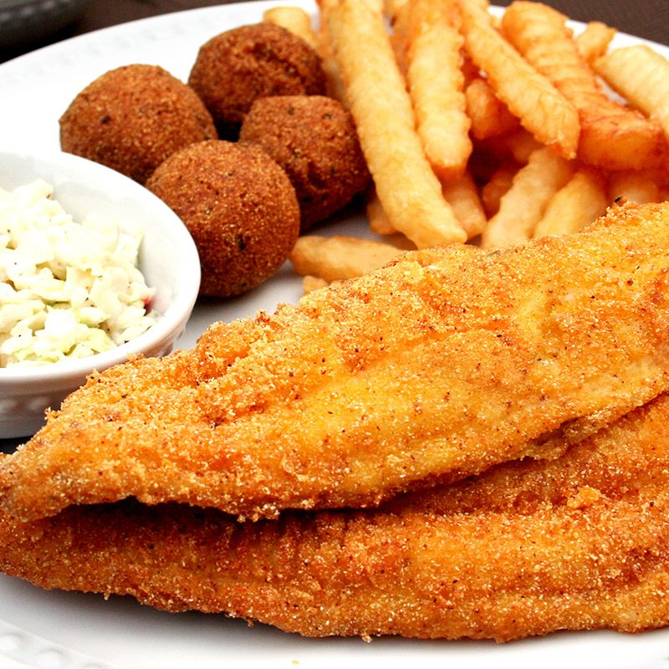
FriedFish
RECIPE

If baking fish instead of frying, use the “Oven-Fried Fish Sandwich” recipe to prepare fish.
INGREDIENTS
- 20 fish fillets, 4 oz. each
- 1/3 cup milk
- 1-2/3 cup cornmeal
- 1-2/3 cup all purpose flour
- 2-1/2 teaspoons salt
- 2-1/2 teaspoons black pepper
- 2-1/2 teaspoons garlic
- 5 teaspoons paprika

For Tartar Sauce
- 1 cup mayonnaise
- 2 tablespoons sweet pickle relish (well drained)
- 1 teaspoon paprika
- 4 teaspoons freshly squeezed lemon juice
- 3 tablespoons sweet onion, very finely chopped

DIRECTIONS
- Preheat deep fryer to 375°F.
- Prepare tartar sauce by combining the mayonnaise, relish, paprika, lemon juice and onion in a small mixing bowl. Refrigerate until ready to use.
- Pour milk in a shallow dish.
- Combine cornmeal, flour, paprika, salt, pepper and garlic in a shallow dish.
- Dredge both sides of fish in milk, then press fillets gently into the cornmeal mixture to be sure they're well coated.
- Drop coated fish carefully into heated oil and allow to cook until fish flakes easily and the coating is crisp and golden, approximately 4 to 6 minutes.
- Remove fish from fryer and place on paper towel to soak up the excess oil. Serve immediately.

Prep Time: 20 minutes | Cook Time: 5 minutes | Total Time: 25 minutes | Yield: 20 servings

