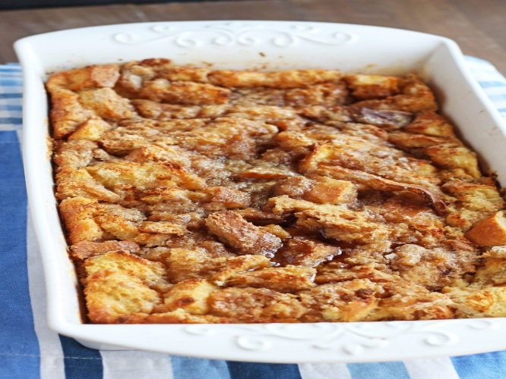
French Toast Casserole
RECIPE

INGREDIENTS
- 3 loaves day-old French bread
- 18 eggs
- 8 ¼ cups milk
- 1 ½ cup sugar
- 3 tablespoons vanilla extract
- 1 tablespoon cinnamon
- Powdered sugar
- Optional Ingredients:
Pecans, walnuts, maple syrup,
nutmeg, powdered sugar, raisins,
craisins

TOPPING INGREDIENTS
- 1 ½ cup packed brown sugar
- ¾ cup flour
- 1 tablespoon cinnamon
- 9 tablespoons cold butter

DIRECTIONS
- Cut bread into cubes or tear into small pieces. Place in a 2-inch pan sprayed with non-stick spray.
- In a medium bowl, whisk together eggs, milk, sugar, vanilla, cinnamon and any desired optional ingredients. Pour over bread in the pan. Cover and refrigerate for 2 hours or overnight.
- Preheat oven to 350 degrees.
- In a small bowl combine brown sugar, flour and cinnamon. Cut butter into small pieces and add to flour mixture. With a fork blend butter into mixture until it resembles small crumbs; sprinkle over bread in the pan.
- Cover with foil and bake for 20 minutes. Uncover and bake for another 20-25 minutes or until golden brown and cooked through. Top with a little powdered sugar.

Prep Time: 20 minutes | Cook Time: 45 minutes | Total Time: 65 minutes | Yield: 18 servings

