Fish Tacos
RECIPE
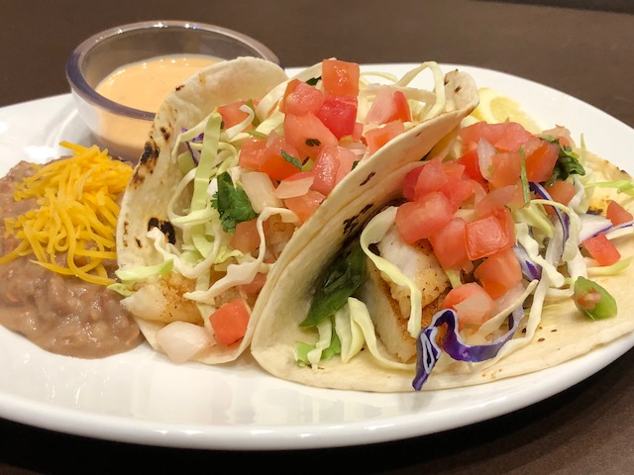
INGREDIENTS
- 40 flour tortillas
- 20 fish fillets 4 oz each
- Seasoning salt
- 1 bag shredded cold slaw mix

For Fish Taco Sauce
- 2/3 cup mayo
- 1 cup sour cream
- 4 tablespoon lime juice
- 1 teaspoon Sriracha sauce or to taste
- 2 teaspoons garlic powder

DIRECTIONS
- Mix together all ingredients until smooth for Fish Taco Sauce and set aside.
- Preheat griddle or pan to medium heat.
- Season both sides of fish with seasoning salt.
- Spray non-stick cooking spray on griddle or pan.
- Place fish on griddle or pan and cook for 3 minutes on each side. (Note: may also place in preheated 350°F oven for 15 minutes or until fish is flaky.)
- Evenly divide fish and place into 2 taco shells. (May cut fish into pieces if preferred.
- Top each taco with cold slaw mix and Pico de Gallo.
- To serve, place 2 tacos on plate along-side a container of fish taco sauce.

Prep Time: 20 minutes | Cook Time: 15 minutes | Total Time: 35 minutes | Yield: 20 servings

