Fish Hobo Pack
RECIPE
INGREDIENTS
- 20 Swai fillets, 3-5 oz each
- Salt and pepper
- Paprika
- Optional seasonings:
Seasoning salt, basil, dill,
onion powder, garlic powder, dried
lemon peel, lemon slices, thyme, chives,
oregano, parsley
Shrimp in place of Swai
- Quinoa and Kale blend
- Vegetable of choice

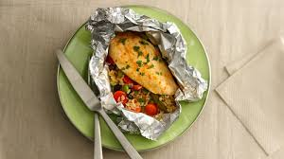

DIRECTIONS
- Tear off a large square of aluminum foil. Place ¼ cup Grains & Kale Blend in center of foil.
- Rinse fish in cold water and pat dry with paper towels.
- Season both sides of fish with salt, pepper and paprika. Season with optional seasonings if desired.
- Lay fish on top of Quinoa Blend and place 1 cup of vegetables around the edges of the fish.
- Seal foil package securely (packages may be frozen if preparing them days ahead).
- When ready to heat and serve, preheat oven to 350 degrees. Bake fish for 15-20 minutes (if frozen, bake approx. 25 minutes) until fish reaches an internal temperature of 165 degrees.

Prep Time: 20 minutes | Cook Time: 15 minutes | Total Time: 35 minutes | Yield: 20 servings

