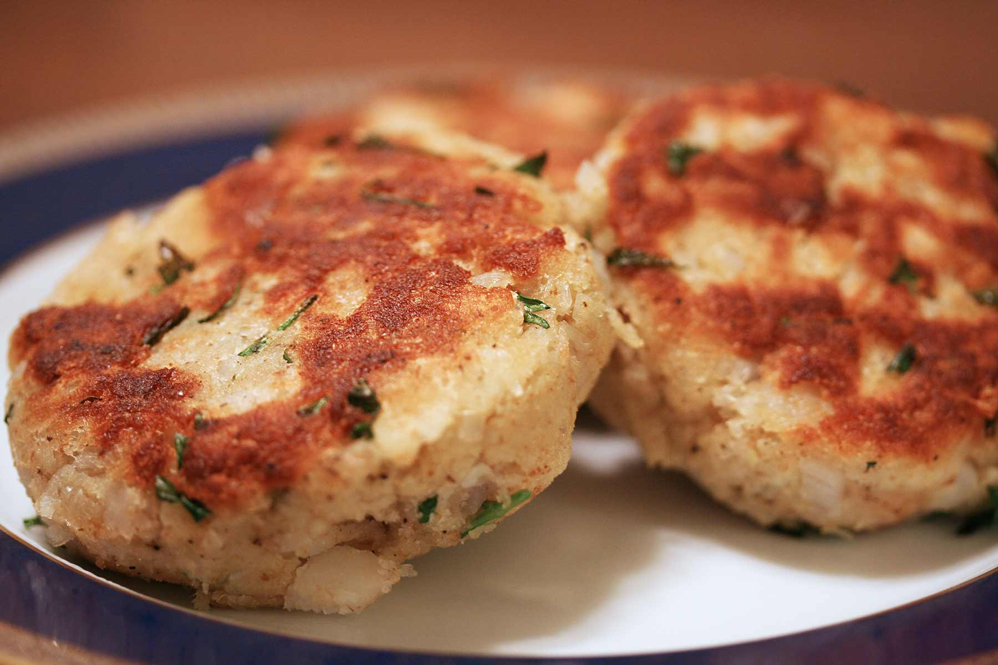
Fish Cakes
RECIPE
INGREDIENTS
- 1 pound cooked fish
- 1½ cups soft bread crumbs
- 3 eggs, beaten
- 1 medium onion, chopped small
- 2 tablespoons mayonnaise
- 1½ teaspoons ground mustard
- 1 teaspoon dried parsley flakes
- ¾ teaspoons salt
- 1 ½ cups seasoned breadcrumbs
- 2 tablespoon oil
- Optional Ingredients:
cayenne pepper, lemon juice, hot sauce, parmesan cheese, cornmeal, green onions, Old Bay, garlic powder, Worcestershire sauce

DIRECTIONS
- In a bowl. Combine first eight ingredients and mix well.
- Shape into 12 patties adding a liquid if needed. Coat patties with seasoned bread crumbs.
- Heat oil in skillet and cook patties for 4-5 minutes on each side or until lightly browned. Serve with your favorite tartar sauce. (Can these then be placed in pan in oven to keep until serve time?)
Try baking instead with some non-stick spray on top. Might try adding some dry breadcrumbs into the cakes if they are sticky. Play with ingredients.

Prep Time: 15 minutes | Cook Time: 5 minutes | Total Time: 20 minutes | Yield: 6 servings

