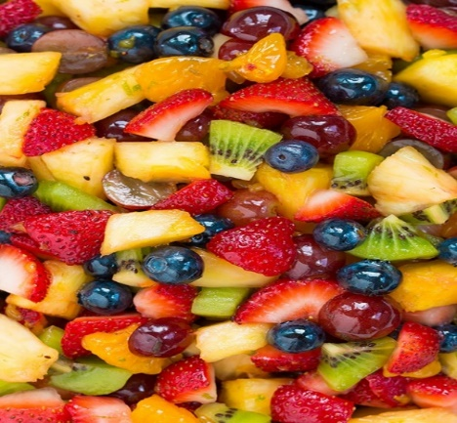
Easy Fruit Salad
Note: Any cut up fruit will work. Main thing is to vary the color so it is eye appealing.

RECIPE
INGREDIENTS FOR ONE TYPE OF GLAZE
- ¾ cup honey
- 2 tablespoons lime zest
- 3 tablespoons fresh lime juice

DIRECTIONS
- Whisk together they honey, lime zest and lime juice. Pour over fruit just before serving and toss to evenly coat (as it sits for a few minutes the juices will gather at the bottom, so toss again before plating).

INGREDIENTS FOR A DIFFERENT TYPE OF GLAZE
- 1 1/3 cup fresh orange juice
- 2/3 cup fresh lemon juice
- 2/3 cup packed brown sugar
- 1 teaspoon grated orange zest
- 1 teaspoon grated lemon zest
- 2 teaspoons vanilla extract

DIRECTIONS
- Bring orange juice, lemon juice, brown sugar, orange and lemon zest to a boil in a saucepan over medium-high heat. Reduce heat to medium-low, and simmer until slightly thickened, about 5 minutes. Remove from heat, and stir in vanilla extract. Set aside to cool. Pour over fruit just before serving and toss to coat.

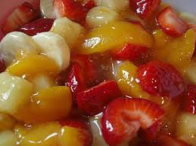

INGREDIENTS FOR A PIE FILLING FRUIT SALAD
- 1 (#10) can pie filling (cherry, but any will work)
- ½ (#10) can pineapple tidbits
- 4-6 cups sliced bananas
- Optional Ingredients:
Fruit cocktail, mandarin oranges, grapes, peaches, strawberries

DIRECTIONS
- Mix together and serve.

Prep Time: 30 minutes | Cook Time: 5 minutes | Total Time: 35 minutes | Yield: 20 servings

