Cucumber Salads
RECIPE
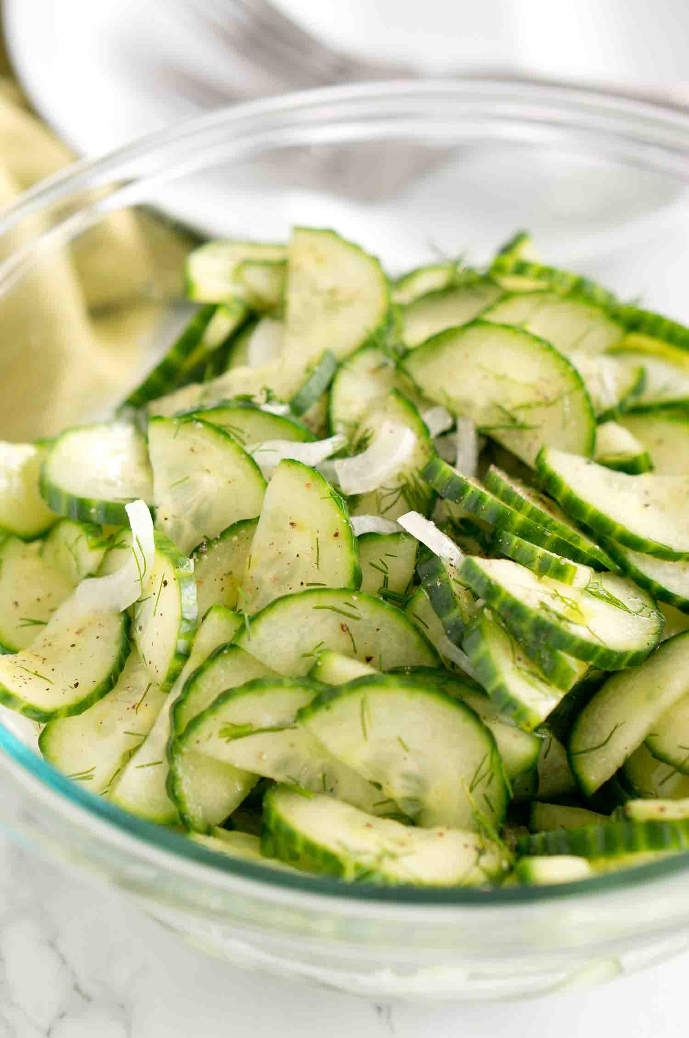
INGREDIENTS
- 6 cucumbers
- 3 medium onion
- 3/4 cup white wine vinegar
- 3/4 cup water
- 3 tablespoons sugar
- Dried dill
- Salt and pepper
DIRECTIONS
- Slice the cucumber in half and then in slices. Slice the onion in thin stripes. Mix cucumber and onions in a large bowl. Season with salt and pepper.
- Mix white wine vinegar, water, sugar in a small bowl. Pour over the cucumbers and onions, and stir well.
- Sprinkle some fresh chopped dill and stir.

DIRECTIONS
- In a medium mixing bowl stir together sour cream, vinegar, dill, sugar, salt, and garlic powder.
- Add cucumbers and red onion; toss to coat.
- Cover and refrigerate 2 or more hours.
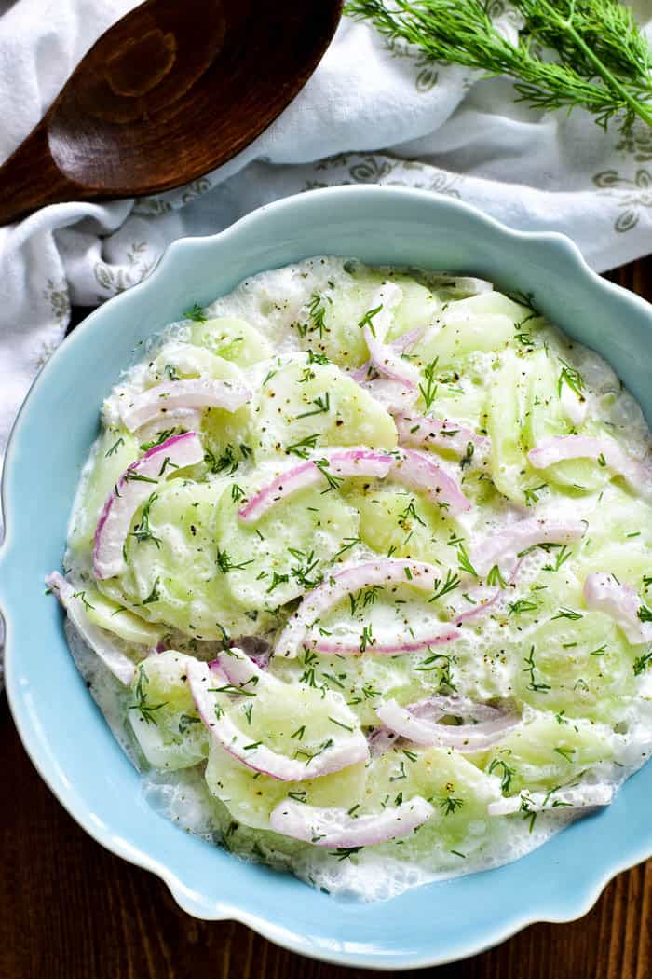
INGREDIENTS
- 9 cups thinly sliced peeled cucumbers
- 3 cups thinly sliced red onion
- 1 ½ cup sour cream
- 3 Tablespoon white vinegar
- 1 teaspoon dried dill
- 1 tablespoon sugar
- ¾ teaspoon garlic powder
- salt

Prep Time: 20 minutes | Cook Time: 0 minutes | Total Time: 20 minutes | Yield: 20-24 servings

