Creamy Parmesan Fish
RECIPE
INGREDIENTS
- 20 fish fillets, 4 oz each
- 2 ½ cups grated Parmesan cheese
- ½ cup + 2 tablespoons butter, softened
- 1 ¼ cup sour cream
- Salt & pepper
- Optional seasonings (½ teaspoon):
Paprika, garlic powder, dill, onion
powder, chives, basil, parsley

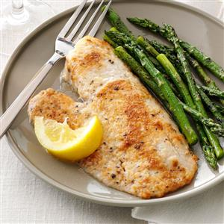

DIRECTIONS
- Preheat oven to 425°F and spray non-stick spray in sheet pan
- Pat fish dry with paper towels removing the moisture ensures they won't get mushy while baking.
- Season fish with salt and pepper and arrange in prepared pan.
- In a bowl, mix together cheese, butter, sour cream and any desired optional ingredient.
- Spread approx. 2-3 tablespoons of cheese mixture over each fillet.
- Bake 10-12 minutes or until fish is cooked and flaky.

Prep Time: 20 minutes | Cook Time: 10-12 minutes | Total Time: 30-32 minutes | Yield: 20 servings

