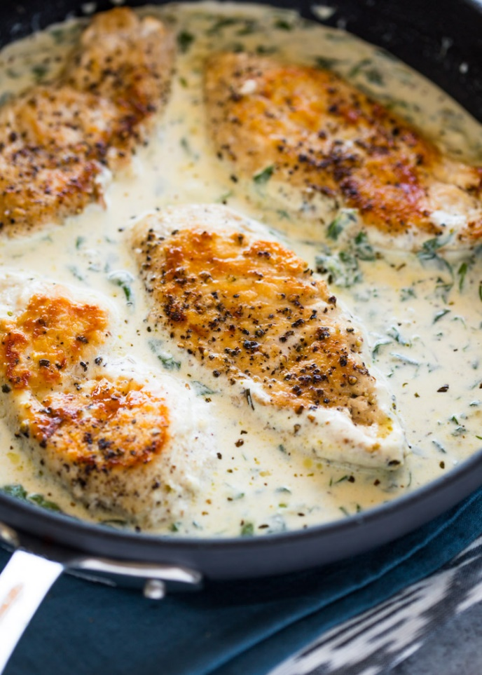
Creamy Garlic Parmesan Chicken
RECIPE

INGREDIENTS
- 24 boneless, skinless chicken breasts
- Salt and pepper
- ¾ cup oil

SAUCE
- 1 ½ cups butter
- 12 cloves garlic, minced
- 6 tablespoons flour
- 3 cups chicken broth
- 3 cups heavy cream
- 3 cups milk
- 2 ½ cup parmesan cheese
- 1 tablespoon garlic powder
- Salt and pepper
- Optional Ingredients:
spinach, mushrooms, oregano

DIRECTIONS
- Preheat oven to 350 degrees. Spray a 2” pan with non-stick spray.
- Season chicken with salt and pepper.
- In a large skillet, add oil and heat to medium-high heat. Brown chicken on each side. Remove and place chicken in prepared pan.
- To make the sauce add butter to skillet to melt. Add garlic and cook until tender. Whisk in flour. Whisk in chicken broth, cream, milk, cheese, garlic powder, salt and pepper until it thickens slightly.
- Pour sauce mixture over chicken and bake 30 minutes until chicken is cooked to 165 degrees and sauce thickens.

Prep Time: 30 minutes | Cook Time: 30 minutes | Total Time: 60 minutes | Yield: 24 servings

