Coleslaw
RECIPE

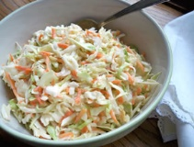
INGREDIENTS
- 1/3 cup vinegar
- 1 cup sugar
- 1 teaspoon dry mustard
- 1 teaspoon salt
- 4 cups mayonnaise
- 1 (5#) bag shredded cabbage mix

DIRECTIONS
- Whisk vinegar, sugar, mustard, and salt together until sugar is dissolved.
- Add mayonnaise and whisk to mix.
- Add slaw mix. Mix to combine. Refrigerate 2 hours and serve.

Prep Time: 10 minutes | Cook Time: 0 minutes | Total Time: 10 minutes | Yield: 32 servings

