Cinnamon Apple Pork Chops
RECIPE
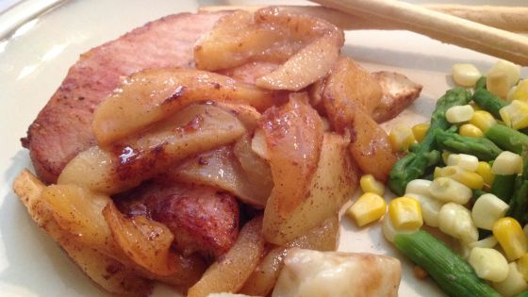
INGREDIENTS
- 24 pork chops
- Salt and pepper
- 1 cup butter
- 16 apples
- 1 cup brown sugar
- 1 tablespoon cinnamon
- Optional Ingredients:
Nutmeg, pecans

DIRECTIONS
- Peel and core the apples.
- Preheat oven to 350 degrees.
- Melt butter in a skillet and brown pork chops on both sides in the butter
- Spray two 2" pans with non-stick spray.
- Add cinnamon and sugar to apples and mix well
- Divide apples and put one half in one pan and the other half in the other pan. Place half of the browned pork chops on top of apples in one pan and then do the same in the other pan
- Cover pans with foil and bake for 1 ½ hours. Internal temperature should be 145 degrees.

Prep Time: 45 minutes | Cook Time: 90 minutes | Total Time: 135 minutes | Yield: 24 servings

