Cinnamon Apples
RECIPE

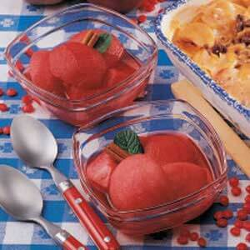
INGREDIENTS
- 8 cups water
- 3 cup red-hot candies
- 1 1/3 cup sugar
- 12 large tart apples, peeled and quartered
DIRECTIONS
- In a large saucepan, bring water, candies and sugar to a boil over medium heat; boil and stir until candies dissolved.
- Reduce heat; carefully add apples. Cook until apples are tender. Transfer apples to bowl; pour sugar syrup over apples. Cool, cover and refrigerate for at least 3 hours.

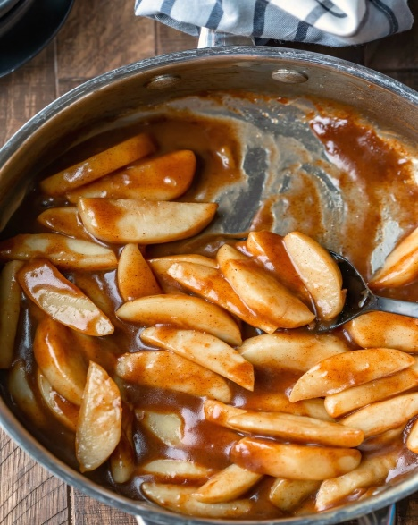
INGREDIENTS
- ¾ cup butter
- 12 large tart apples, peeled & sliced 1/4 inch thick
- 2 tablespoons cornstarch
- 1 ½ cup cold water
- 1 ½ cup brown sugar
- 1 ½ teaspoons cinnamon
DIRECTIONS
- In a large saucepan, melt butter over medium heat; add apples. Cook, stirring constantly, until apples are almost tender, about 6 to 7 minutes.
- Dissolve cornstarch in water; add to skillet. Stir in brown sugar and cinnamon. Boil for 2 minutes, stirring occasionally. Remove from heat and serve warm.

Prep Time: 10 minutes | Cook Time: 15 minutes | Total Time: 25 minutes | Yield: 24 servings

