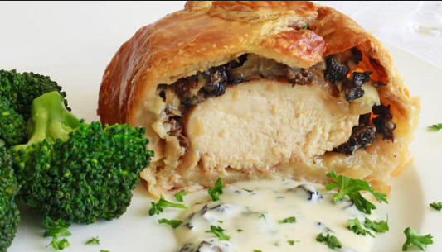
Chicken Wellington
INGREDIENTS
- 24 boneless skinless (4 oz) chicken breasts
- 1 tablespoon olive oil
- 1 teaspoon paprika
- 1 tablespoon dill
- 1 tablespoon garlic powder
- 1 tablespoon onion powder
- Salt and pepper
- 24 puff pastry sheets
- 2 eggs & water (egg wash)

DUXELLE INGREDIENTS
- 1/8 cup melted butter
- 2 ½ pounds sliced mushrooms
- 1 medium yellow onion diced
- 1 teaspoon thyme
- 1 tablespoon garlic minced
- 1 tablespoons parsley
- Salt and pepper
- 1/8 cup dry sherry cooking wine
- ½ pound softened cream cheese
- 1 tablespoon dry mustard

RECIPE
Note: This recipe might be better served for a special occasion and not a regular menu item due to the cost of the puff pastry sheets unless budget allows.

DIRECTIONS
- Preheat oven to 400 degrees. Line sheet pans with parchment paper.
- Sauté butter, mushrooms, onions, thyme, parsley, garlic and mustard until vegetables are tender. Deglaze pan with cooking wine. Break cream cheese apart into smaller units and add to pan to melt. Once cream cheese is melted, set aside and let cool.
- Place olive oil in a bowl. Add paprika, dill, garlic powder, onion powder, salt and pepper. Add chicken and coat well. On stove, sear chicken breasts on both sides.
- Lay out squares of puff pastry. Place a yellow handled scoop of duxelle mixture onto pasty square. Lay chicken on top. Carefully stretch and bring corners of pastry sheet up over chicken. Brush edges with egg wash that overlap.
- Place seam side down and brush with egg wash. Bake for 45 minutes. Internal temperature should be 165 degrees.

Prep Time: 45 minutes | Cook Time: 45 minutes | Total Time: 90 minutes | Yield: 24 servings

